RURAL WOMEN HEALTH STATUS ANALYSIS AND EDUCATION IN 25 VILLAGES
Organized By : BUDDHA OUTCAST SOCIAL SOCIETY - INDIA .
Supported By : ASSOCIATED COUNTRY WOMEN OF THE WORLD, UK.
***************************************************************************
CASE STUDY (TWO STORIES OF OUR BENEFICIARIES)
CASE STUDY – 1
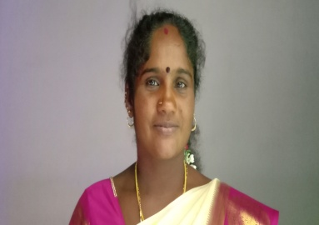
Name : Mrs. B. THAMILZHINI, Age 32 years. Village name: Adaiyur
“I belong to scheduled caste – DALIT community. BOSS Organization have conducted the program of Health Education Programs for promotion of Positive Health Seeking Behaviour among women, young women and adolescent girls and for prevention of common communicable diseases that includes HIV/AIDS/STDs in the general population. In the recent past particular emphasis is given towards the prevention of Covid 19 / Corona Education for the promotion of maternal and child health – education of pregnant women and their families. Organization of health education programs on primary health care and first aid for adolescent girls, AIDS / HIV prevention and awareness education to women SHGs.
BOSS NGO Organization the program of of health education programs on primary health care and first aid for adolescent girls Identification ad selection of participants based on their interest and willingness and motivation – the process will involve consultations with self-help groups of women in my project village. Thanks to BOSS NGO & ASSOCIATED COUNTRY WOMEN OF THE WORLD, UK.”.

CASE STUDY – 2
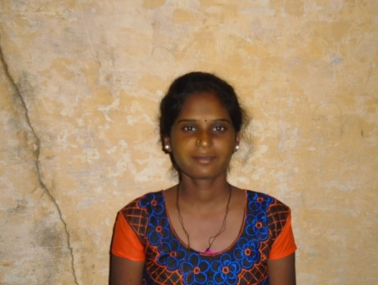 Name : Mrs. K.EZHILARASI,
Aged about : 30 years.
Village Name : Paliyappattu
-----------------------------------------------------------
“I belong to Scheduled tribes community families of our community live in this village, and others are belonging to high caste families that are affluent and dominant castes in the village. Due to caste discrimination, the challenge we faced is that we are not allowed to government hospital in our village.
Malnutrition is common among the women in the villages. Many women are found to be suffering from anemia. Many deliveries take place in the home situation and in the hands of untrained traditional birth attendants or by relatives. The health seeking behavior of women is so poor that they postpone seeking qualified medical help until they become seriously ill and are bedridden.
In our village The diseases that will be spread will include Malnutrition, Reproductive tract Infections, tuberculosis, communicable diseases, Personal hygiene, Hypertension, leprosy, filariasis (elephantiasis) and Covid 19 / Corona , BOSS NGO have conducted the Rural women health status analysis and education on our village .The program included health consultation with health awareness education and causation, spread, early signs and symptoms, availability of treatment facilities, cost factor et. Now we are happy to have the proper health awareness and treatment throughout the day.! Thanks for BOSS NGO & ASSOCIATED COUNTRY WOMEN OF THE WORLD, UK.”.

